Project Design Phase-II Technology Stack (Architecture & Stack)

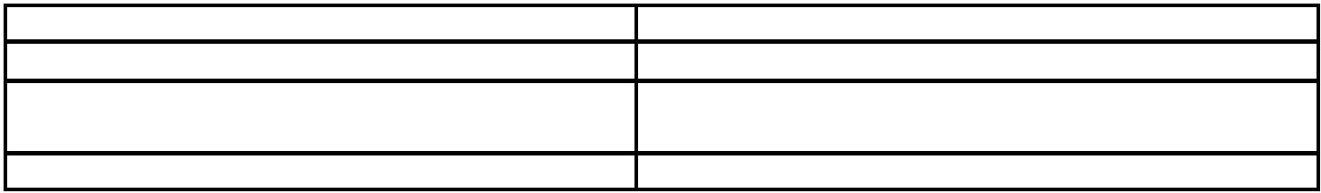

Date Team ID

Project Name

Maximum Marks

27 October 2022 PNT2022TMID54187

Fertilizers Recommendation System For Disease Prediction

4 Marks

**Technical Architecture:**

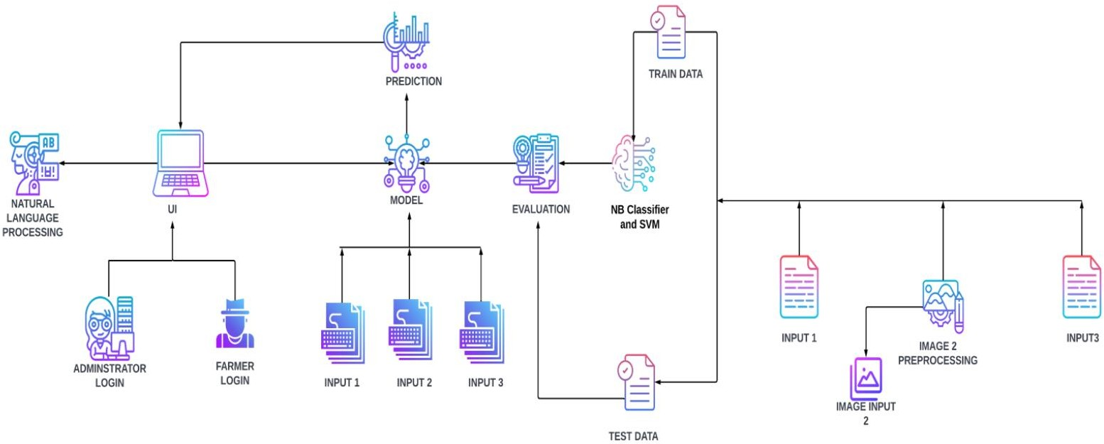

**Table-1 : Components & Technologies**

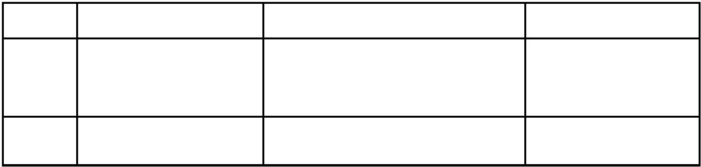

**S.No**

**Component**

**Description**

**Technology**

1.

User Interface

2.

Application Logic-1

How the user interacts with the application .To depict the human-computer interaction and communication.

A page to upload images as input

HTML, CSS,JSP

Python

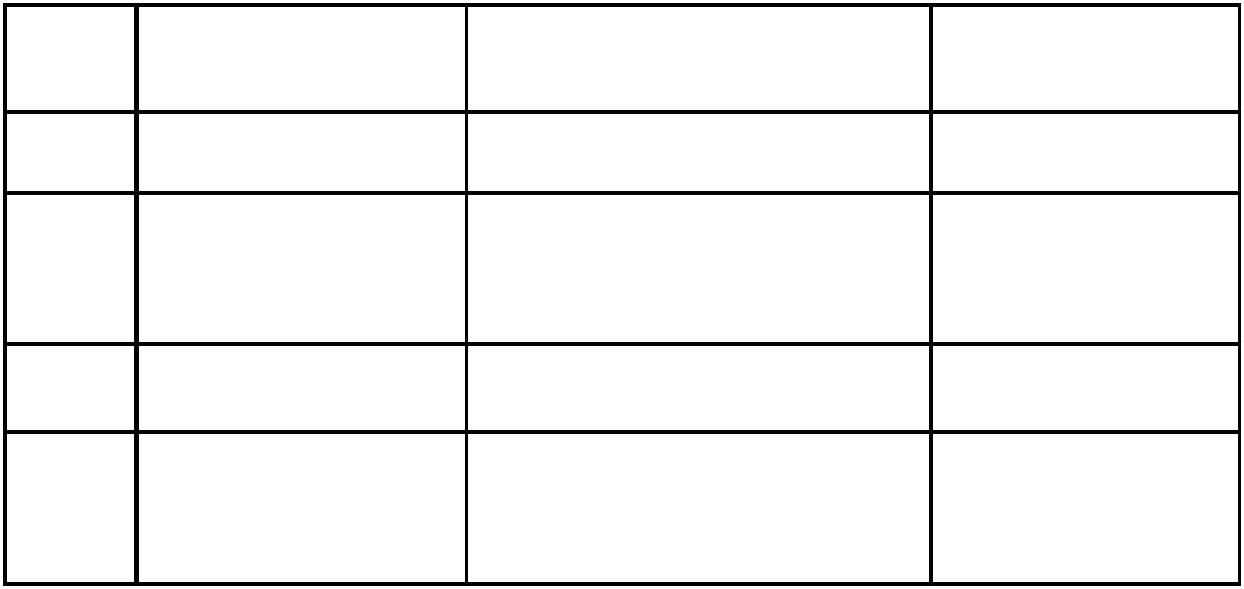

3.

Application Logic-2

4.

Database

To use the Machine Learning model and predicting the result

Structured data-images

Python

MySQL

5.

Cloud Database

Database that typically runs on a IBM Cloud cloud computing platform and access Databases for to the database is provided as-a- MySQL service

6.

File Storage

To store data in a hierarchicalstructure Local File system

7.

Machine Learning Model

Here, we use a Support Vector Machine Algorithm that is used widely in Classification and Regression problems.

Random Forest ,XG Boost

**Table-2: Application Characteristics:**

**S.No Characteristics Description Technology**

1. Open-Source Frameworks

Flask micro web framework Written in Python. It is classified as a micro frame work because it does not require particular tools or libraries. It has no database abstraction layer, form validation, or any other

components where preexisting

third-party libraries provide common functions.

1. Security Implementations With all aspects of the job,

including detecting malicious attacks, analyzing the network, endpoint protection and vulnerability assessment, Sign in encryption

IBM Cloud App ID Services



3.

Availability

Available for all data size

-

4.

Performance

Can extend the storage according to our needs

Python,AngularJS